
Sreenidhi Institute of Science and Technology
(An Autonomous Institution)
Regulations:
A14
Code No: 4AC41 Date:5-Dec-16(FN)
B. TECH. II-Year I-Semester Examinations, Nov/Dec 2016 (Supplementary)
BASIC ELECTRICAL ENGINEERING (Common to ME, CSE and IT)

Time: 3 Hours Max. Marks: 70
Note: a) No additional answer sheets will be provided.
b) All sub-parts of a question must be answered at one place only, otherwise it will not be valued.
c) Assume any missing data.

Part - A
Max.Marks:20

Answer all QUESTIONS. EACH QUESTION CARRIES 2 MARKS.

- Define KCL and KVL.
- Define R.M.S value
- Explain what do you mean by an Ideal transformer.
- List out the types of DC machines.
- What are the different torques in electrical Instruments?
- What is the relation between line current and phase current in a delta connected system.
- Define instantaneous power and average power of a given electrical circuit
- Obtain the equivalent Star circuit of a given delta circuit with equal resistance ‘R’ in all branches.
- Explain the effect of damping in electrical instruments?
- What is slip Explain?

Part – B
Max.Marks:50

ANSWER ANY FIVE QUESTIONS. EACH QUESTION CARRIES 10 MARKS.
1. Reduce the network shown in fig.(1) below using source transformation across the terminals ‘A’ and ‘B’ (10M)
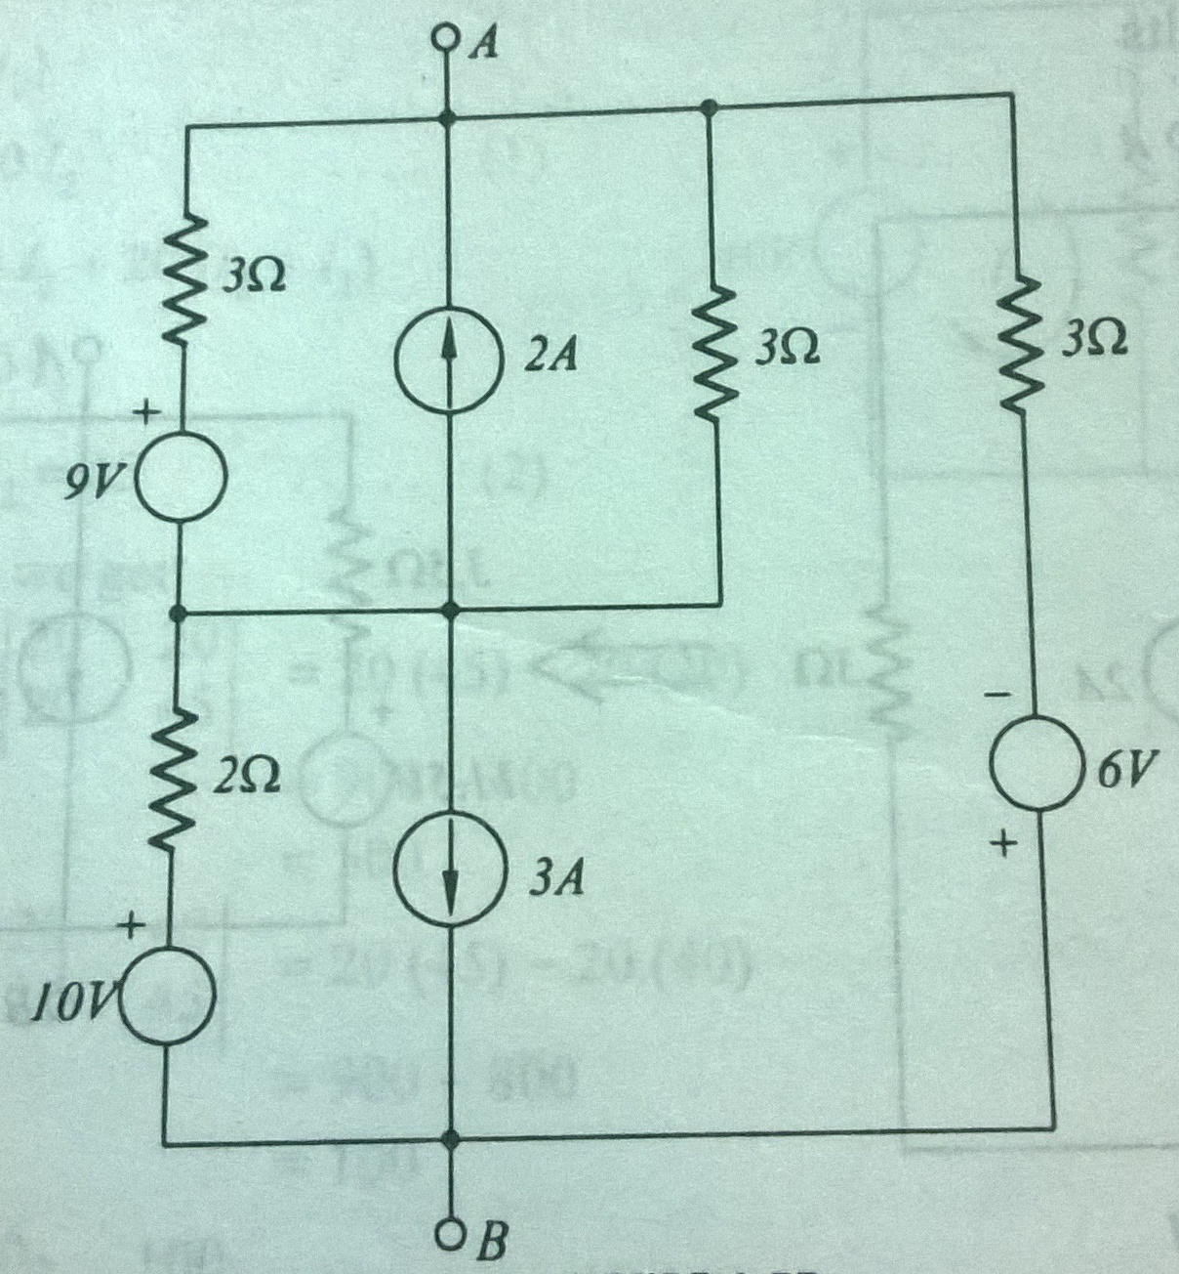
Fig. 1

2. (a)Explain how a sinusoidal quantity can be represented by the phasor. (4M)
(b)Find the values of R₁ and X₁ when a lagging current in the circuit gives a power of 2KW. (6M)
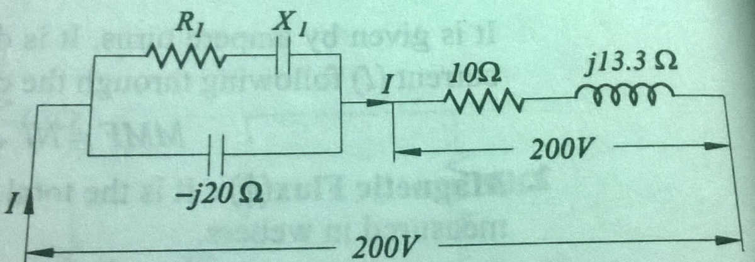

Fig. 2

3.(a) Deduce the expression for e.m.f in a transformer and give the expressions for voltage ratio and turns ratio. (6M)
(b) A 25KVA, single phase transformer has 250 turns on the primary and 40 turns on the secondary winding. The primary is connected to 1500volt, 50Hz mains. Calculate (4M)
- Primary and secondary currents on full load
- Secondary EMF

4.(a) Explain the principle of operation and working of a DC shunt motor. (5M)
(b) Draw the speed characteristics of DC machine and explain. (5M)

5.(a) Explain the principle of operation of three phase Induction motor. (5M)
(b) A 4 pole 3-phase induction motor operates from a supply whose frequency is 50Hz. Calculate
- The speed of the rotor when the slip is 0.04
- The frequency of the rotor when the slip is 0.03 (5M)

6.Give a brief treatise on the requirements of indicating instruments. (10M)

7.(a) Describe with suitable diagrams the principle of operation of DC generator. (5M)
(b) What are the advantages and disadvantages of a separately excited generator over a self excited generator? (5M)

8. (a) Derive a general expression for the torque developed in a 3-phase induction
motor. (5M)
(b) Explain the principle of working of permanent magnet moving coil instrument.(5M)

-- 00 -- 00 --

